|  |  |
| --- | --- |
| ID number | #1 |
| Name | **The text on the page is not formatted correctly** |
| Reporter | Sanja Vasiljevic |
| Submit Date | 24/04/2022 |
| URL | http://www.gatesnfences.com/index.html |
| Platform | Windows 10 Pro Version 21H2 |
| Operating System | OS build 19044.1645 |
| Browser | Google Chrom Version 100.0.4896.127 |

**Steps to reproduce**

1. Open the http://www.libertyvan.com/ page
2. Check the formation of the text on the page, the text on the page is not formatted correctly, there is no consistency in font type, font size and color. The text on the page has no meaningful parts.

**Screenshot**

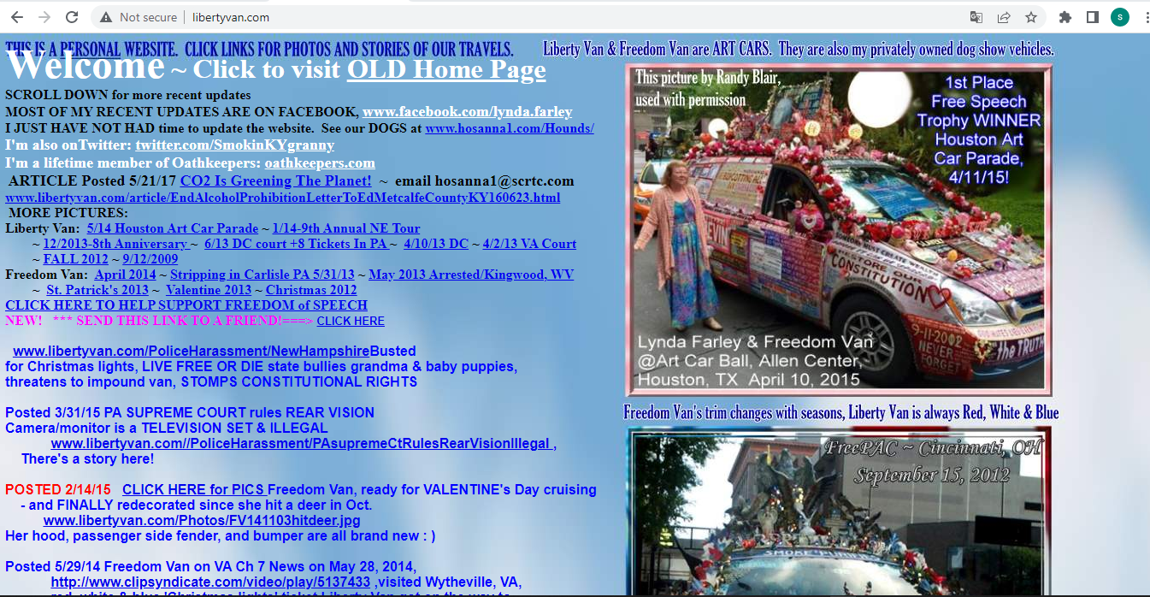

|  |  |
| --- | --- |
| ID number | #2 |
| Name | **Text on the page is overlapping** |
| Reporter | Sanja Vasiljevic |
| Submit Date | 24/04/2022 |
| URL | http://www.gatesnfences.com/index.html |
| Platform | Windows 10 Pro Version 21H2 |
| Operating System | OS build 19044.1645 |
| Browser | Google Chrom Version 100.0.4896.127 |

**Steps to reproduce**

1. Open the http://www.libertyvan.com/ page
2. Check the first line of the text on the page

**Screenshot**

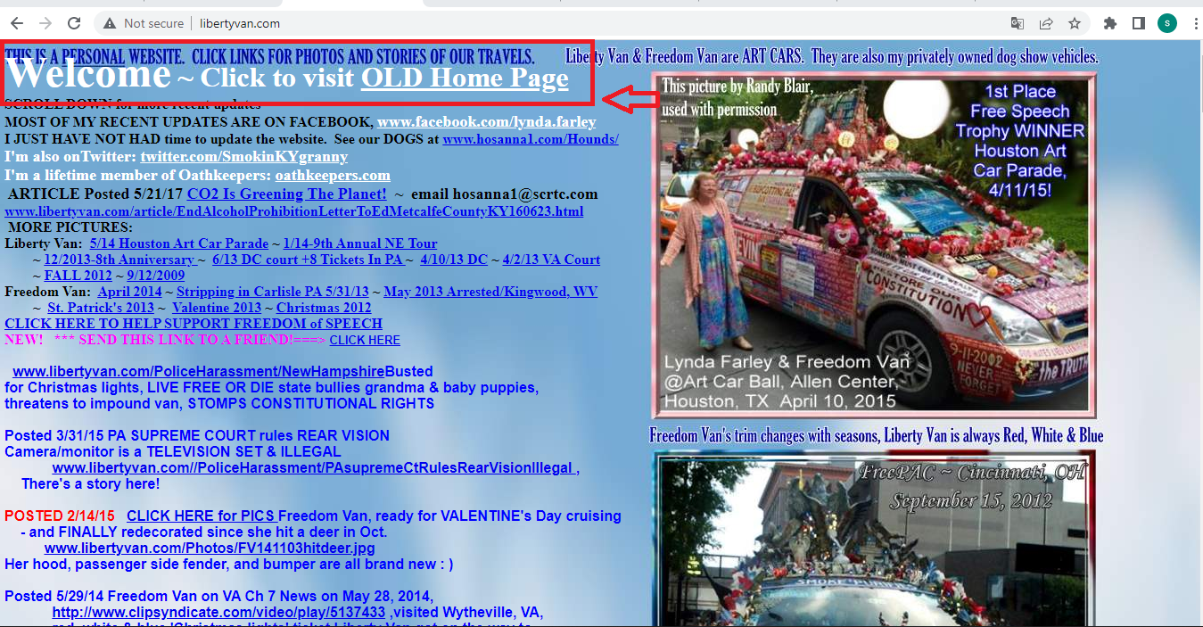

|  |  |
| --- | --- |
| ID number | #3 |
| Name | **Text of the link to the oathkeepers.org page is wrong** |
| Reporter | Sanja Vasiljevic |
| Submit Date | 24/04/2022 |
| URL | http://www.gatesnfences.com/index.html |
| Platform | Windows 10 Pro Version 21H2 |
| Operating System | OS build 19044.1645 |
| Browser | Google Chrom Version 100.0.4896.127 |

**Steps to reproduce**

1. Open the http://www.libertyvan.com/ page
2. Click on the [oathkeepers.com](http://oathkeepers.org) text link
3. The link is taking you to the <https://oathkeepers.org/> page
4. The domain extension of the text link is wrong

**Screenshot**

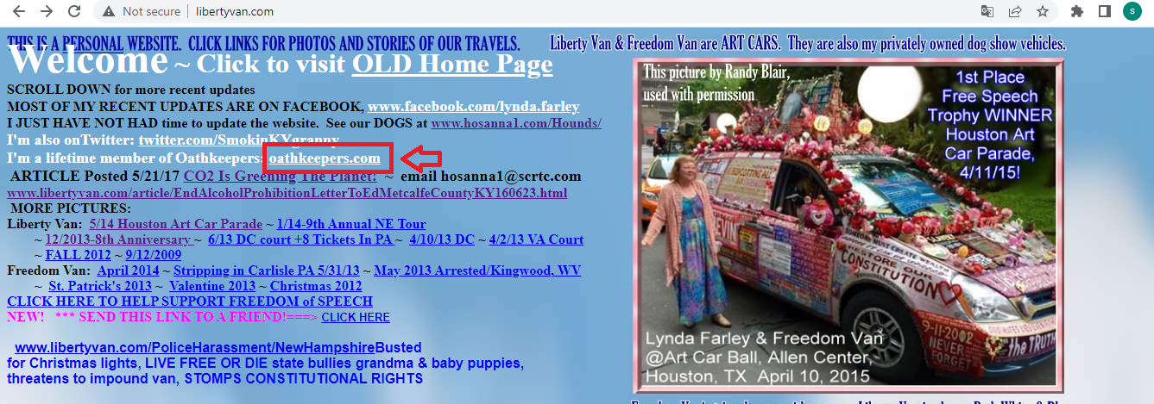

|  |  |
| --- | --- |
| ID number | #4 |
| Name | **The 5/14 Houston Art Car Parade link is not opening in the new tab** |
| Reporter | Sanja Vasiljevic |
| Submit Date | 24/04/2022 |
| URL | http://www.gatesnfences.com/index.html |
| Platform | Windows 10 Pro Version 21H2 |
| Operating System | OS build 19044.1645 |
| Browser | Google Chrom Version 100.0.4896.127 |

**Steps to reproduce**

1. Open the http://www.libertyvan.com/ page
2. Click of the **5/14 Houston Art Car Parade** text link
3. The new page is opened in the same tab, while other links open in a new tab, such as this one: ([here](http://www.libertyvan.com/article/CO2IsGreeningThePlanet/index.html))

**Screencast**

[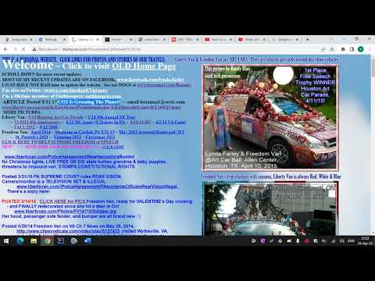](https://www.youtube.com/embed/fLyDHR4YI4s?feature=oembed)

|  |  |
| --- | --- |
| ID number | #5 |
| Name | **The text is overlapping the webpage’s theme picture** |
| Reporter | Sanja Vasiljevic |
| Submit Date | 24/04/2022 |
| URL | http://www.gatesnfences.com/index.html |
| Platform | Windows 10 Pro Version 21H2 |
| Operating System | OS build 19044.1645 |
| Browser | Google Chrom Version 100.0.4896.127 |

**Steps to reproduce**

1. Open the http://www.libertyvan.com/ page
2. Check the text on the page
3. Some parts of text have poor visibility due to overlapping the theme image
4. You can notice this on many parts of the page while scrolling down

**Screenshots**

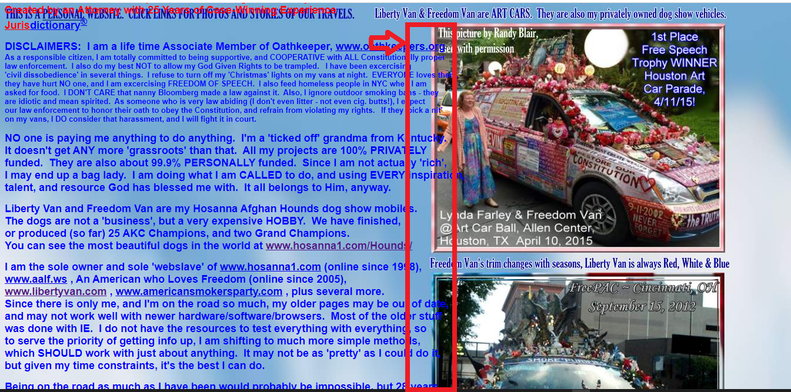

|  |  |
| --- | --- |
| ID number | #6 |
| Name | **The contents of the page are overlapping** |
| Reporter | Sanja Vasiljevic |
| Submit Date | 24/04/2022 |
| URL | http://www.gatesnfences.com/index.html |
| Platform | Windows 10 Pro Version 21H2 |
| Operating System | OS build 19044.1645 |
| Browser | Google Chrom Version 100.0.4896.127 |

**Steps to reproduce**

1. Open the http://www.libertyvan.com/ page
2. Scroll down to the part where the theme picture is starting again
3. Check the text
4. The contents of the page are overlapping in a way that the content is not readable.

**Screenshot**

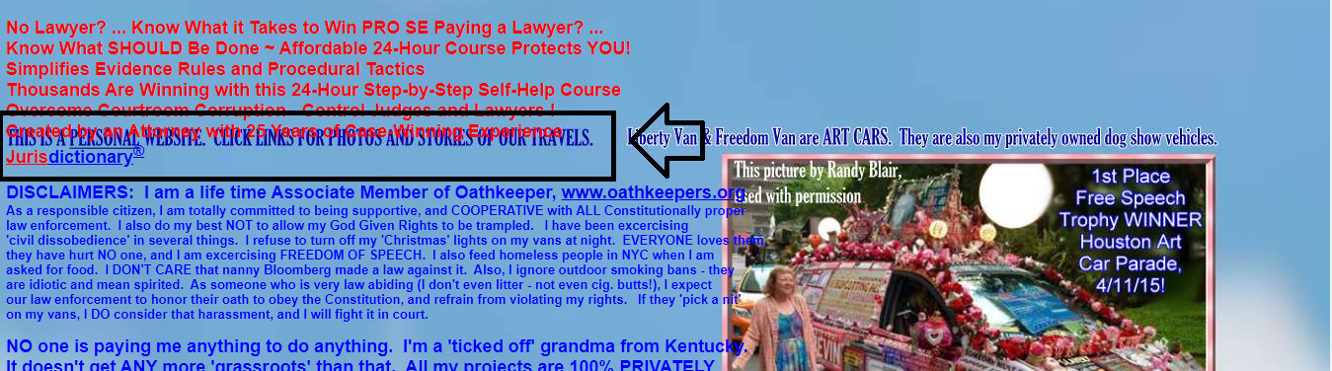

|  |  |
| --- | --- |
| ID number | #7 |
| Name | **The text *http://www.americansmokersparty.com/Kentucky/* has two links that lead to the page** |
| Reporter | Sanja Vasiljevic |
| Submit Date | 24/04/2022 |
| URL | http://www.gatesnfences.com/index.html |
| Platform | Windows 10 Pro Version 21H2 |
| Operating System | OS build 19044.1645 |
| Browser | Google Chrom Version 100.0.4896.127 |

**Steps to reproduce**

1. Open the http://www.libertyvan.com/ page
2. Click on the **www.americansmokersparty.com/** text link
3. The link is taking you to the http://www.americansmokersparty.com/Kentucky/ page
4. If you click on the **Kentucky/** part of the text, it will lead you to the same page

**Screenshot**

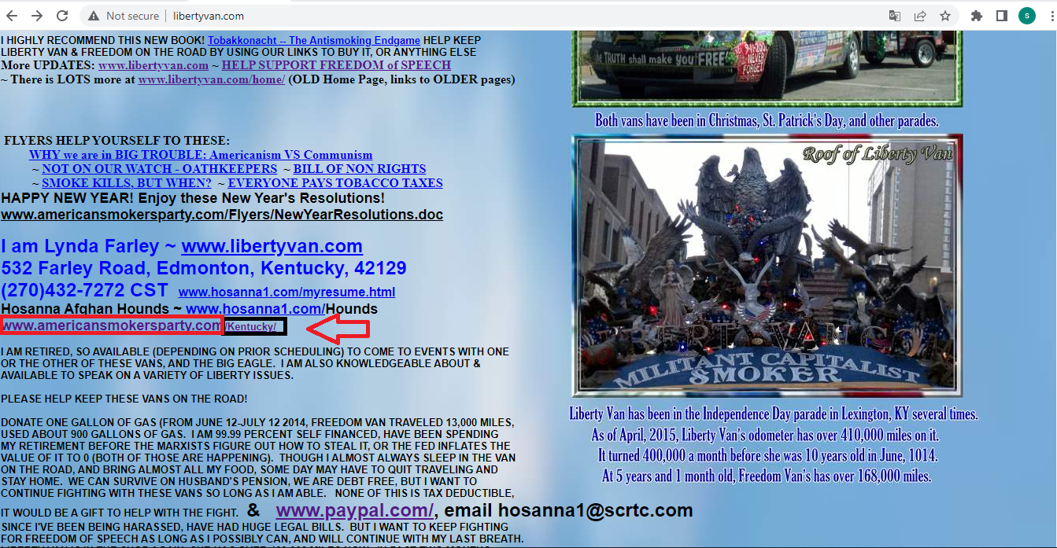

|  |  |
| --- | --- |
| ID number | #8 |
| Name | **Text of the link to the http://www.hosanna1.com/Hounds/ page is wrong** |
| Reporter | Sanja Vasiljevic |
| Submit Date | 24/04/2022 |
| URL | http://www.gatesnfences.com/index.html |
| Platform | Windows 10 Pro Version 21H2 |
| Operating System | OS build 19044.1645 |
| Browser | Google Chrom Version 100.0.4896.127 |

**Steps to reproduce**

1. Open the http://www.libertyvan.com/ page
2. Click on the www.hosanna1.com/ text link
3. The link is taking you to the http://www.hosanna1.com/Hounds/ page
4. The text of the link is missing a part

**Screenshot**

